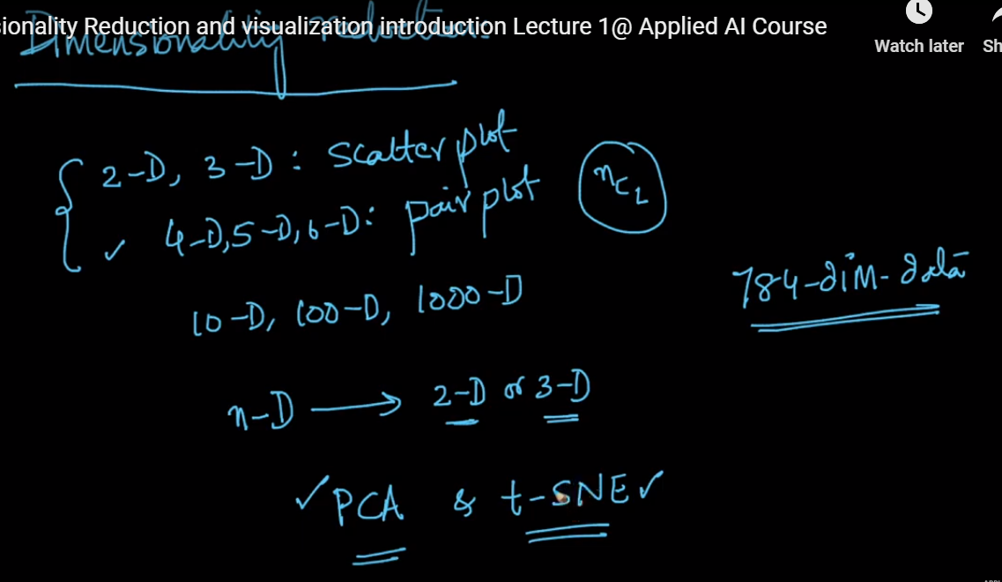

Dimensionality reduction helps in visualizing dataset with 10D or more dimensions.

Dimensionality reduction is the process by which higher dimensional data is transformed into lower dimensional data